**Power BI Capstone Project**

**Bank loan Performance Analysis**

**Project Title**

Bank Loan Performance Analysis

**Problem Statement**

In today's data-driven world, understanding how borrower details and loan

characteristics impact loan performance is very important for banking institutions. This

project seeks to delve deep into a lending loan dataset to uncover the relationship

between borrower behavior (such as employment length, income, and debt-to-income

ratio) and loan characteristics (including amount, term, and interest rate) to unearth

critical insights into loan performance metrics. By examining patterns in loan statuses

such as fully paid, charged off, or late payments, this analysis aims to empower banking

institutions with actionable insights to optimize loan lending strategies, mitigate credit

risk, and enhance overall portfolio performance**.**

**Dataset Download**

https://drive.google.com/uc?export=download&id=1yNL9gfv-DlD3cEW9o2GJvtJ9Bzbm37R7

The dataset "bank loan.xlsx" contains two sheets:

1. **Loan Details**: This sheet contains information about each loan.

2. **Borrower Details**: This sheet provides details about the borrowers.

|  |  |  |
| --- | --- | --- |
| Table of Content | | |
| s.no | **Title** | **Page No** |
| 1 | Data Dictionary | 2 |
| 2 | Import Data | 3 |
| 3 | Transformation Using Query | 3 |
| 4 | Data Modeling | 9 |
| 5 | Create Measure and Calculated columns using DAX | 10 |
| 6 | Create Comprehensive Report | 11 |

**Data Dictionary**

**Table 1Transformation**

|  |  |  |
| --- | --- | --- |
| Table name | Filed name | Description |
| Loan Details | Id | Unique identifier for each loan. |
| Loan-amount | The amount of money requested by the borrower. |
| Funded-amnt | The actual amount of money funded for the loan. |
| Term | The duration of the loan in months. |
| Int-rate | The interest rate of the loan. |
| Installment | The monthly payment owed by the borrower. |
| Grade | The loan grade assigned by the lending company. |
| Sub-grade | The loan subgrade assigned by the lending company. |
| Issue-d | The month in which the loan was funded. |
| Purpose | The reason provided by the borrower for the loan. |

**Table 2**

|  |  |  |
| --- | --- | --- |
| Table Name | Field Name | Description |
| Borrower Details | Id | Unique identifier for each loan. |
| member_id | Unique identifier for each borrower. |
| emp_length | Employment length in years. |
| home_ownership | The status of home ownership reported by the borrower. |
| annual_inc | The annual income reported by the borrower. |
| verification_status | Indicates if the borrower's income was verified. |
| Dti | The debt-to-income ratio of the borrower. |
| delinq_2yrs | The number of past-due incidences in the borrower's credit file. |
| last_pymnt_d | The month of the last payment received. |
| total_pymnt | The total amount received in payments. |
| out_prncp | The remaining outstanding principal amount of the loan. |

**Project Steps**

**1) Importing Data**

➢ Import the "Loan Details" and "Borrower Details" sheets from the "bank loan.xlsx"

file into Power BI.

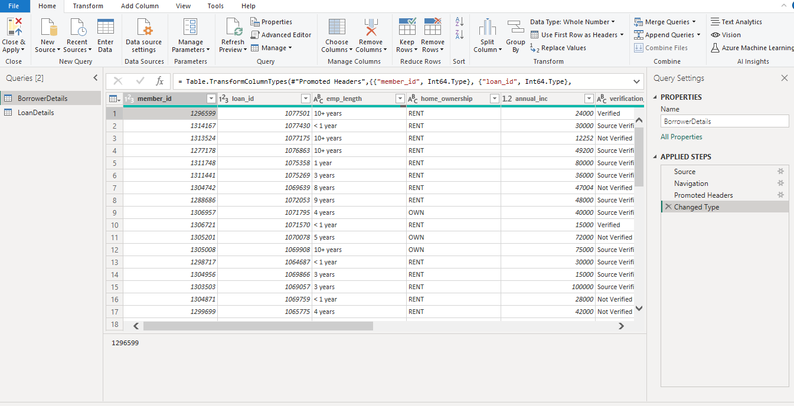

**2) Transformation Using Power Query**

**Data Cleaning**

**Handling Missing Values and Duplicates**

➢ Replace missing values (null) in the 'emp_length' column of the "Borrower Details"

table with '0 year'.

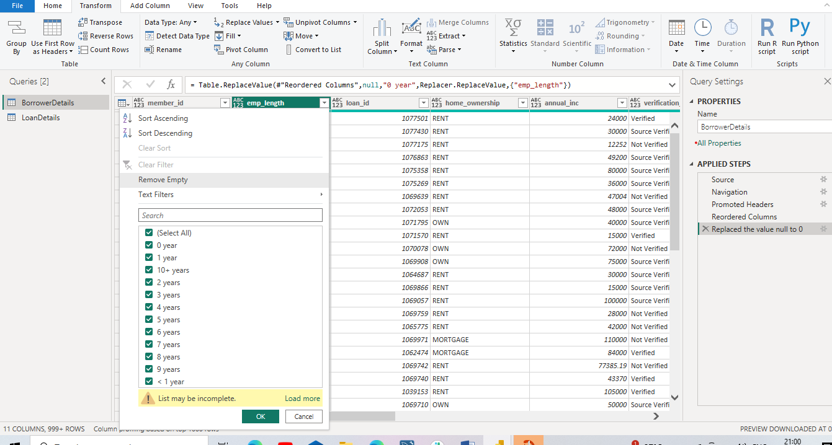

➢ Remove rows with missing values in the 'last_pymnt_d' and 'delinq_2yrs' columns.

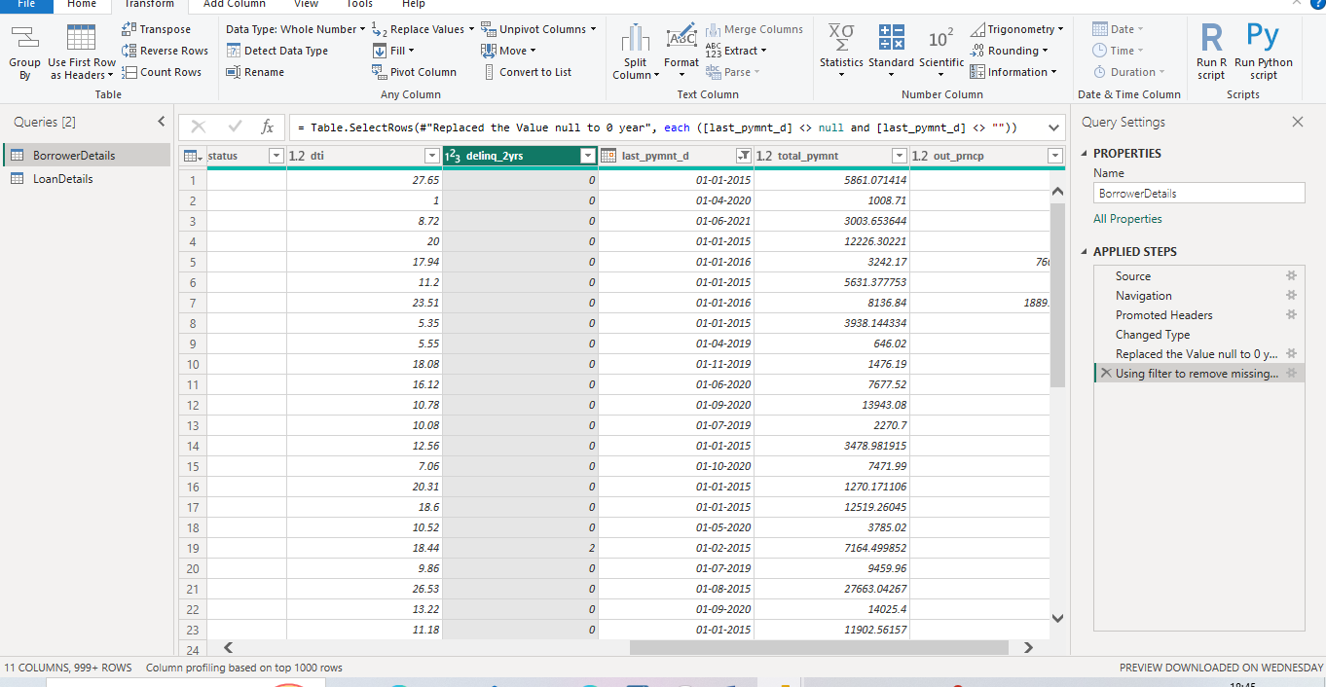

➢ Remove duplicate rows in the 'id' column of the "LoanDetails" table.

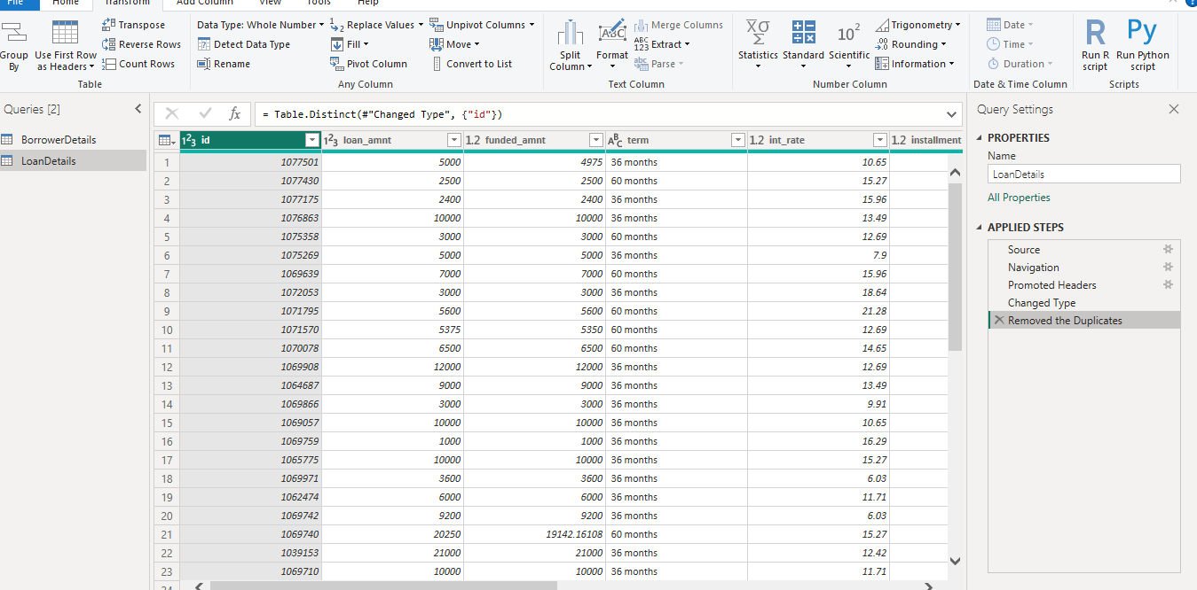

**Dealing with Inconsistencies**

➢ Ensure words in the 'purpose' column are separated by spaces instead of

underscores (e.g., "credit card" instead of "credit_ card").

➢ Format the 'purpose' and 'home _ownership' columns to proper case.

Action 1

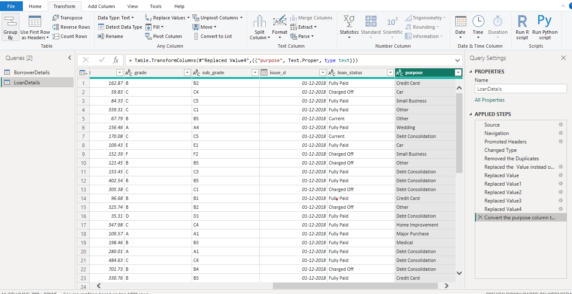

Action 2

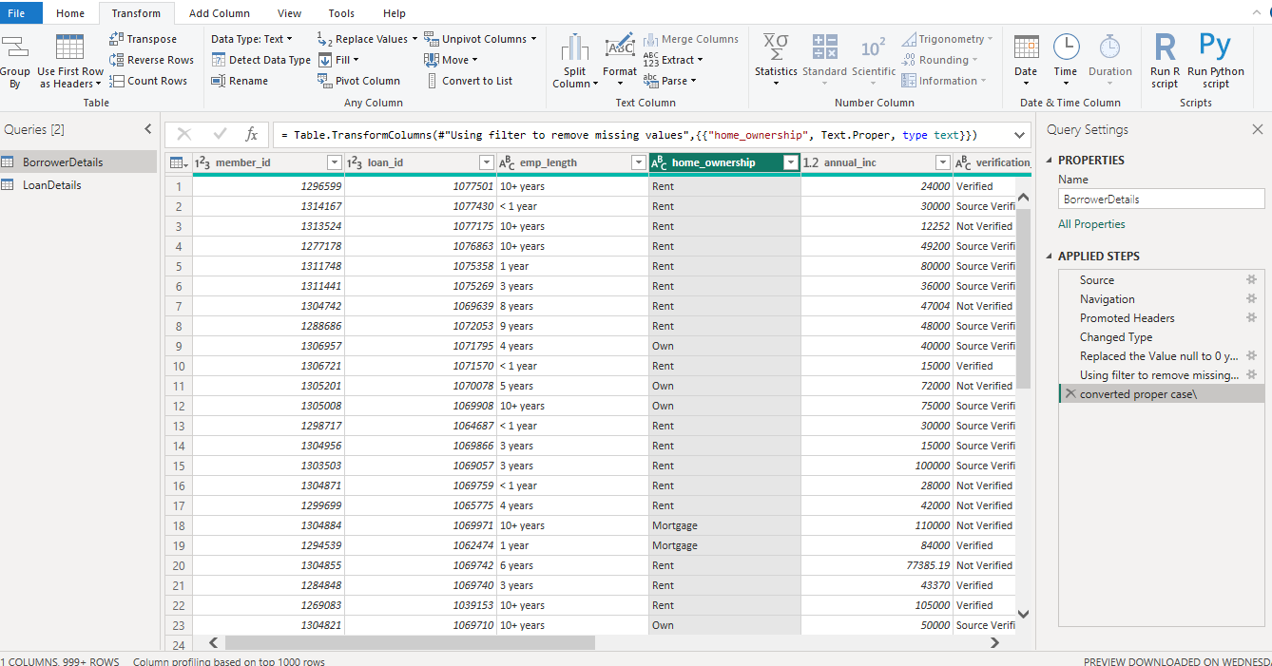

**Data Transformation**

**Column Transformation:**

➢ Change the data type of the 'total_ pymnt' column to 'Fixed decimal number'.

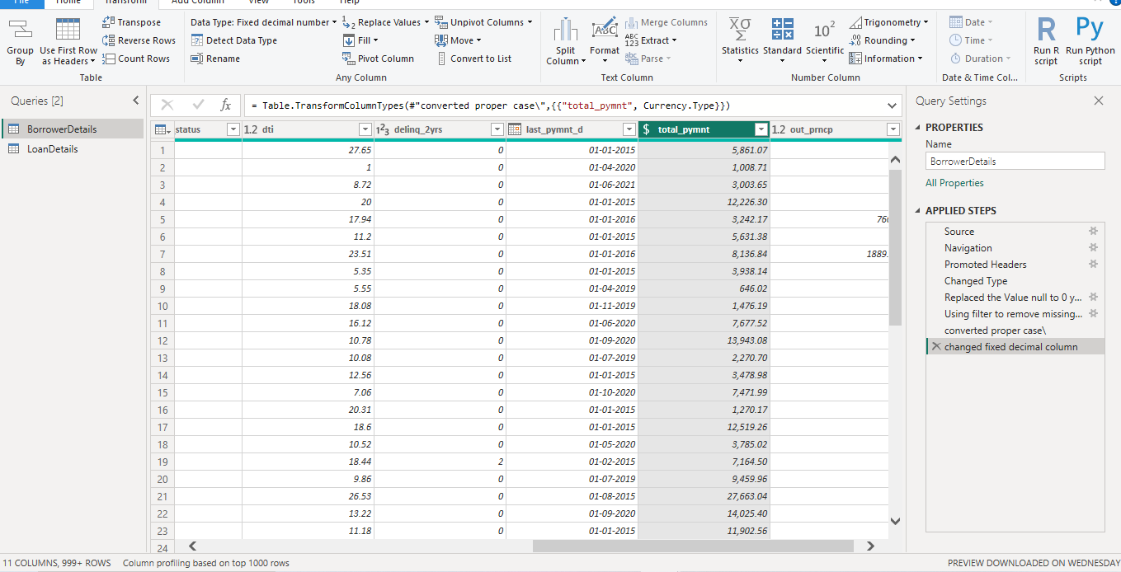

➢ Round off the numbers in the 'funded_amnt' column to 2 decimal places.

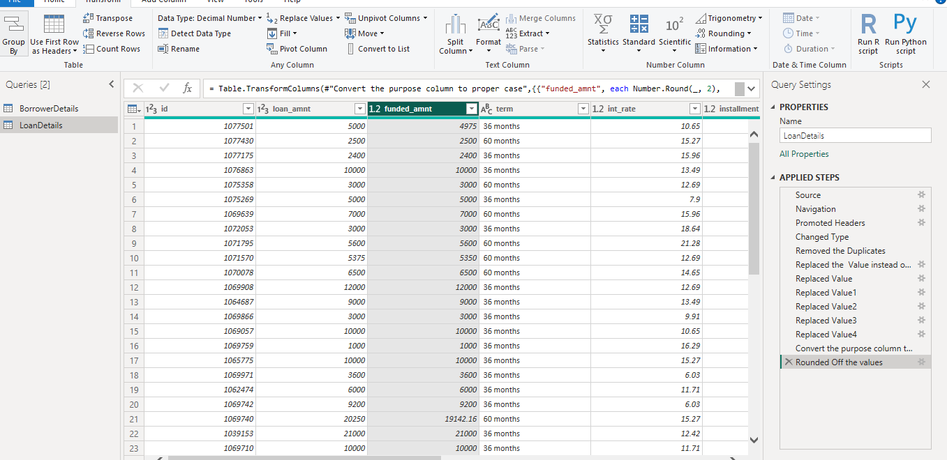

**Column Renaming:**

➢ Rename the column 'issue_ d' to 'issue_ date'.

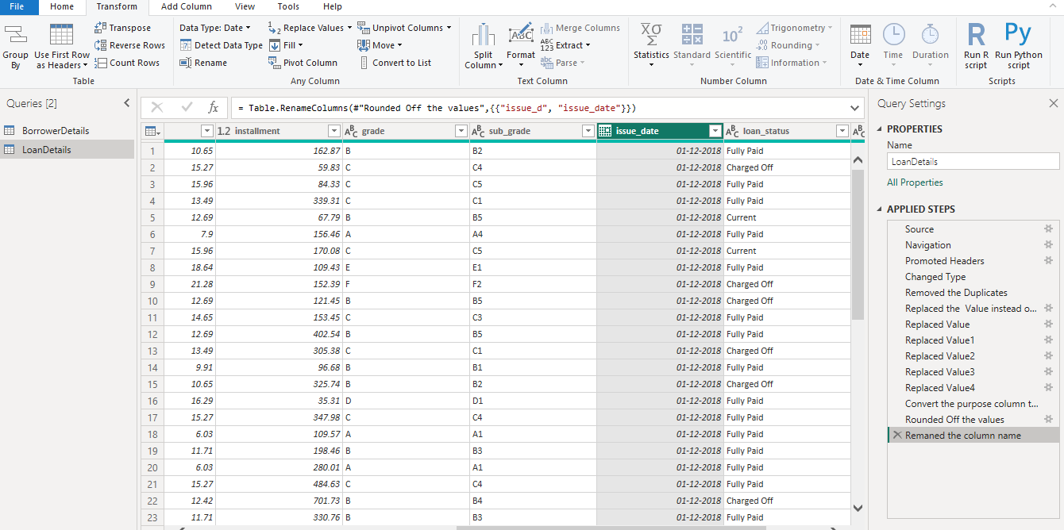

➢ Rename the column 'last_ pymnt_d' to 'last _pymnt_ date'.

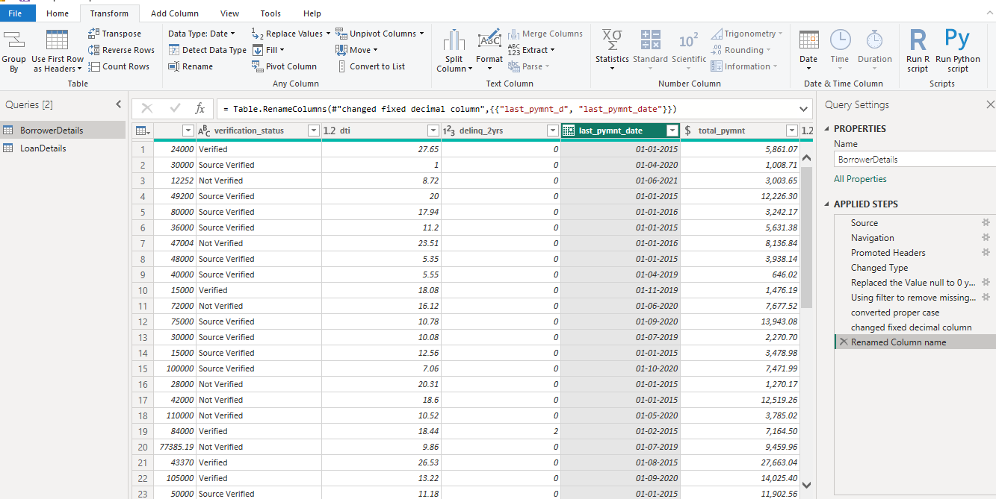

**Creating New Columns**

➢ Create a new custom column named 'total_ amount_ paid' to calculate the total

amount paid by each borrower by subtracting 'out_ prncp' from 'total_ pymnt'.

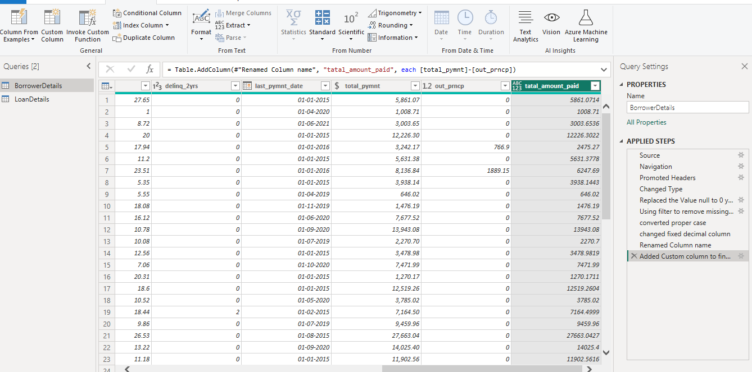

➢ Add a new conditional column named 'delinquency_status' to identify if the

borrower has any delinquencies. If the number of delinquencies in 'delinq_2yrs' is

greater than 0, the status should be "Delinquent", otherwise "Not Delinquent".

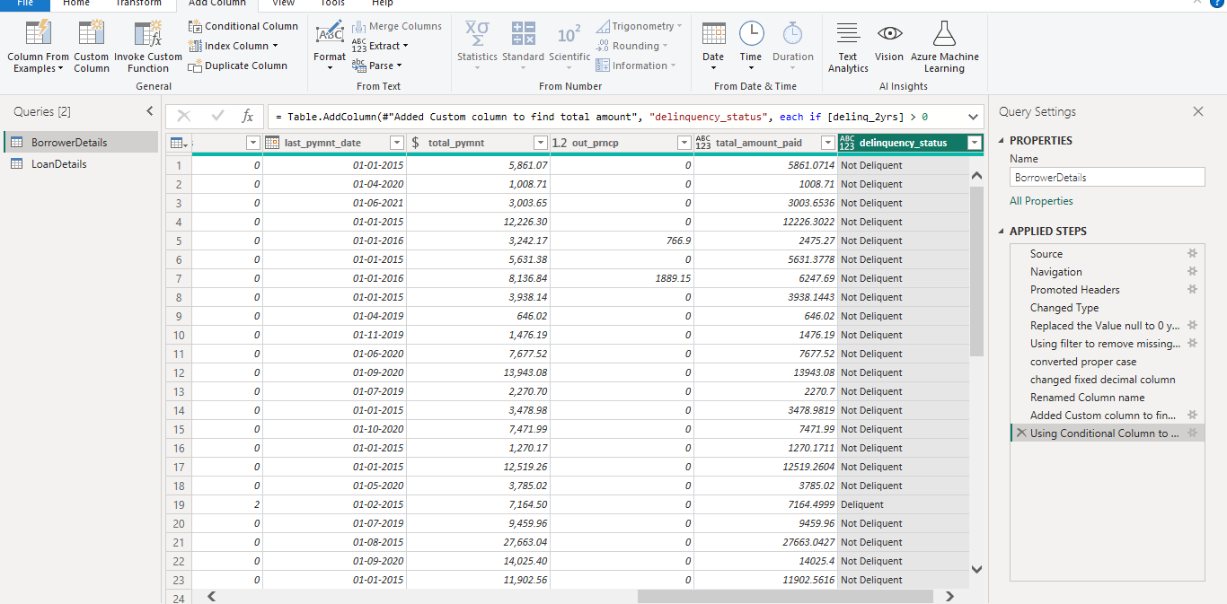

**Column Dropping**

➢ Remove the 'sub_grade' column as that does not significantly contribute to the

analysis.

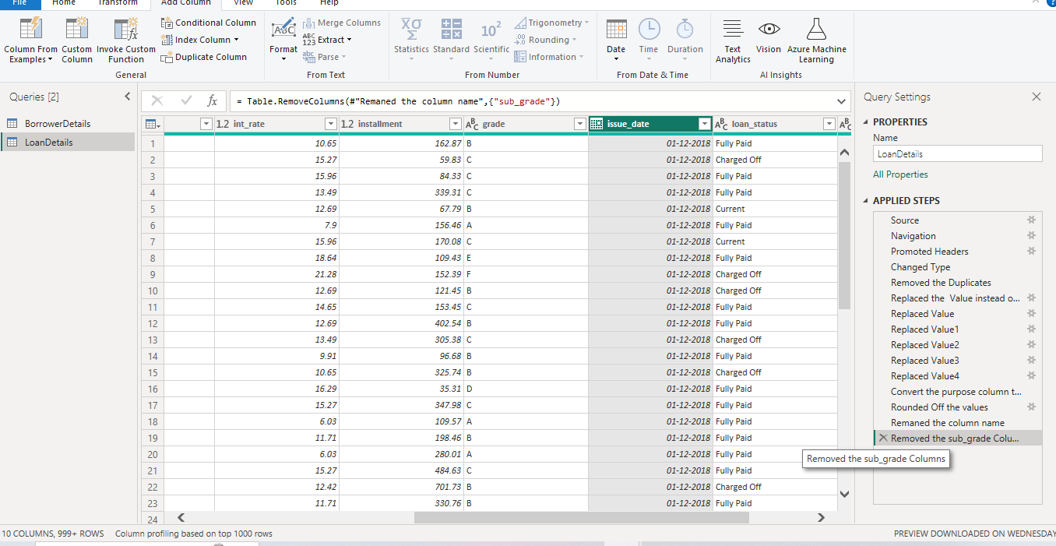

**3) Data Modeling**

➢ Identify the common column between both the tables and establish relationships

between the two tables. Ensure the cross-filter direction is set to "Both". This step

is crucial for enabling cross-table analysis and ensuring data integrity within the

dataset.

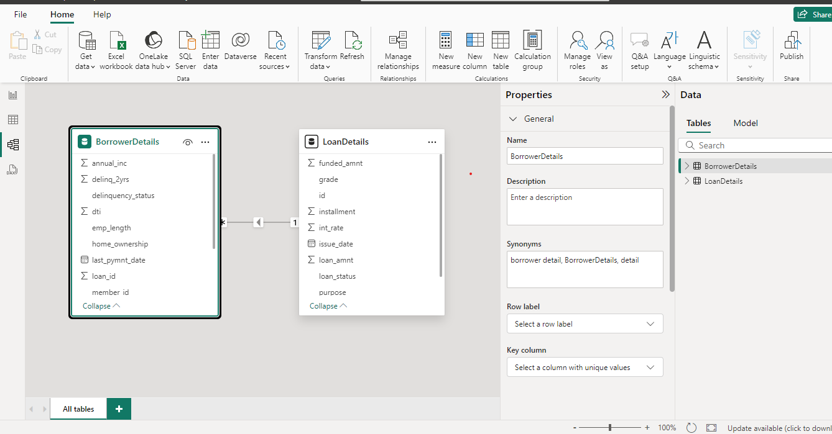

**4) Creating Measures and Calculated Columns using DAX**

➢ Create a new calculated column named 'remaining_installments' using DAX in the

"BorrowerDetails" table to calculate the number of remaining installments by

dividing the remaining principal amount ('out_prncp') by the monthly installment

amount ('installment') and round up the result using the CEILING() function to

account for any partial payments.

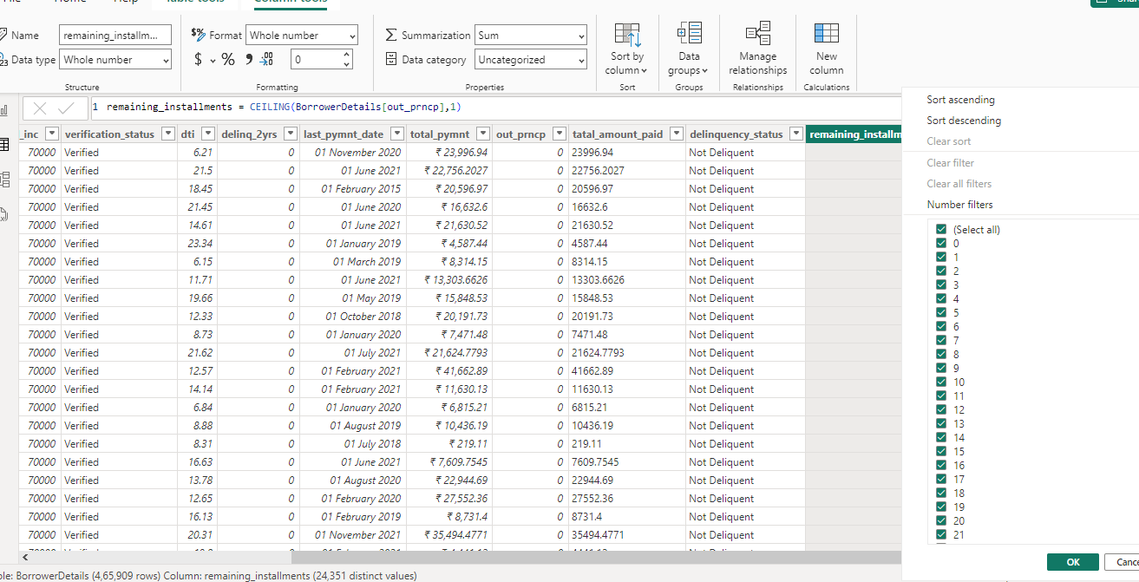

➢ Create a measure named 'Non-Verified Borrowers Count' using DAX to count the

number of loans that have been 'Not Verified'.

➢ Create a measure named 'Fully Paid Loan Percentage' to calculate the percentage

of fully paid loans. Divide the number of loans with a "Fully Paid" loan status by

the total number of loans and then format this measure as Percentage.

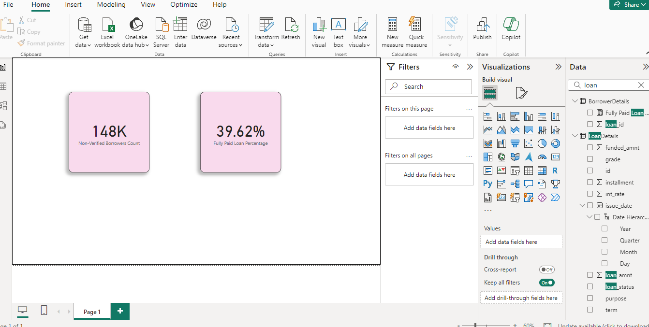

5) Creating Comprehensive Reports

**General Instructions for Report**

➢ Create two insightful reports:

★ **Report 1**: Loan Performance Analysis

**★ Report 2**: Borrower Profile Analysis

➢ Ensure each report and its charts are titled appropriately for easy identification.

➢ Maintain a clean and professional layout throughout both reports.

➢ Format and customize the charts to enhance visual appeal and comprehension.

➢ Utilize slicers for dynamic data exploration and filtering.

➢ Add tooltips to provide additional context and details for data points when

hovered over.

➢ Include a summary or key insights section in each report to highlight main

findings and observations.

Report 1: Loan Performance Analysis

The Loan Performance Analysis report aims to provide insights into the performance

of loans based on various factors such as loan amount, loan status, term, interest rate,

and purpose.

➢ Total Funded Amount: Create a card visual to display the total funded amount.

➢ Fully Paid Loan Percentage: Create a gauge chart to display the 'Fully Paid Loan

Percentage' measure.

➢ Average Interest Rate by Term: Create a multi-row card to show the average

interest rate for each term.

➢ Loan Status Distribution: Create a pie chart to visualize the sum of total

payments by loan status.

➢ Loan Amount by Purpose: Create a treemap to show the average loan amount by

purpose.

➢ Installment Over Time: Create a line chart to visualize the sum of installments by

Year and Quarter of the issue date.

➢ Maximum Total Amount Paid by Loan Status: Create a column chart to display

the maximum total amount paid by loan status.

➢ Minimum Annual Income by Grade: Create a funnel chart to show the minimum

annual income by grade.

➢ Issue Date Slicer: Add a slicer for the Month of the issue date to enable dynamic

data exploration.

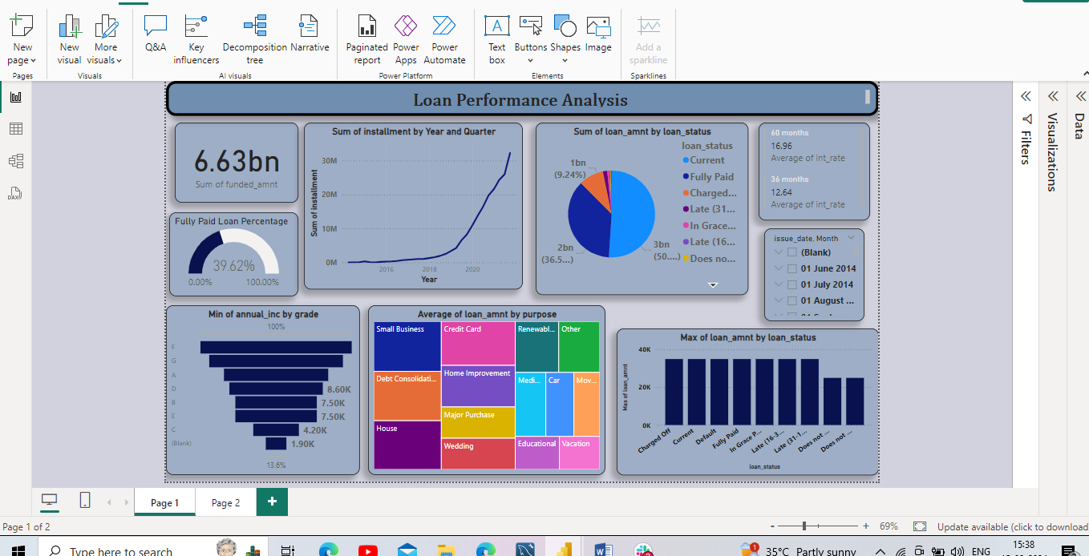

Report 2: Borrower Profile Analysis

The Borrower Profile Analysis report aims to provide insights into the characteristics of borrowers such as home ownership, annual income, employment length, verification status, debt-to-income ratio, and delinquency history.

**➢ KPI Visual**: Create a KPI visual with the sum of total payment as the value, the

year of last payment date as the trend axis, and the sum of loan amount as the

target. Round off to 2 decimal points and format as $ currency.

➢ **Average of Annual Income**: Display the average of annual income using a card

visual.

➢ **Non-Verified Borrowers Count:** Display the count of non-verified borrowers using

a card visual.

**➢ Average Debt-to-Income by Delinquency Status:** Create a multi-row card to show

the average debt-to-income ratio by delinquency status.

➢ **Sum of Loan Amount by Home Ownership:** Create a table to show the total loan

amount by home ownership.

**➢ Average Remaining Principal by Verification Status**: Create a donut chart to

display the average remaining outstanding principal by verification status.

➢ **Sum of Delinquencies by Home Ownership:** Create a bar chart to show the total

number of delinquencies in the past 2 years by home ownership and filter the

visual to display only Mortgage, Rent, and Own.

➢ **Max Remaining Installments by Employment Length:** Create a treemap to show

the maximum remaining installments by employment length.

**➢ Total Amount Paid and Funded Amount Over Time:** Create a line chart to display

the sum of total amount paid and the sum of funded amount by the year of last

payment date.

➢ **Purpose Slicer:** Add a slicer for loan purpose to enable dynamic data exploration.

